ITGC Control CCW CA19

As in onramp role features:

* what properties are configured for each role in the onramp, that is CA19
* they are checking if all the admin roles have been for revalidation
* if all the SOX roles have got proper approvers configured
* If any role is non-SOX, we have to give explanation on why it is non -SOX
* By mistake if it is non-SOX, we have to check with the appropriate team and put it back to the SOX.
* That validation we do in CA-19

**CCW CA19 for Order:**

* For order we have both provisioning as well as Assassin Script. So which ever application got Assassin Script enabled, user sync is required for that
* If there is no Assassin script then we have to do both user and Role sync
* First we have to take what roles are available in the application for order
* we have to take all the roles from the role table, the query will be

Application Query:

SELECT a.role_id,a.role_name,a.role_description,a.active,b.onramp_resource_id,

FROM co_order-role a,dmadm.co_order_role_onramp_mapping b

WHERE a.role_id=b.role_id

ORDER BY ENV_NAME

* If we run the above query that will give list of all rows which are there in the application
* We will get application roles data dump with the OnRamp resource id along with application id
* In the same way we have to run the query from OnRamp also
* so there is standard query in onramp, all applications in CA19 the same query will be used to get the report from onramp

OnRamp Query:

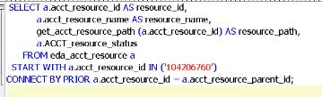

* so all the roles under this particular PROD path will be displayed using this query
* These also will be having both “active” and “inactive”
* “Inactive” means it was there in the UI once and then it got removed and we added some other role.so that will become 0.
* So now we got all the roles from application and all the roles from OnRamp, now we have to perform the sync between these two:

a. Roles in onramp

b. Roles in application

we have to perform VLOOKUP,so entire data from this query (or) roles from “application”

* So if we observe Role names will be different in application and OnRamp,so we cannot perform sync (mapping) based on role name.So we are taking the resource id along with the role names

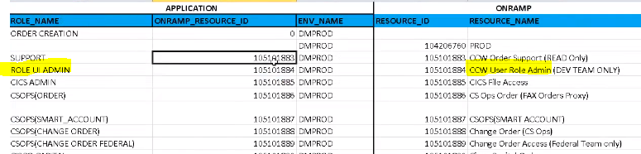

* So we can put up sync based on this resource id
* After performing sync wherever we have “false” ,we have to put a comment saying why this is not in OnRamp or viceversa(not in application) recource id is 0 ,so this “Inactive Role”
* If we see role “ORDER CREATION” in above screenshot ,resource id is 0.so it is inactive role.Thats why it is not present in ONRAMP
* And Parent resource id will not be there in the application
* So same way we have to check if anything false so Stage environment roles which are configured in the application are false.so we are taking only the PROD path in Onramp so all those will be false
* 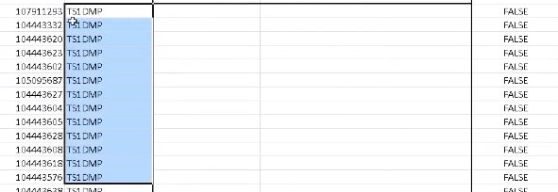
* So this is how we will be performing the “role sync”

**Resource Hierarchy:**

We can get the resource hierarchy report with resource id in onRamp and validate the appropraite columns from the report

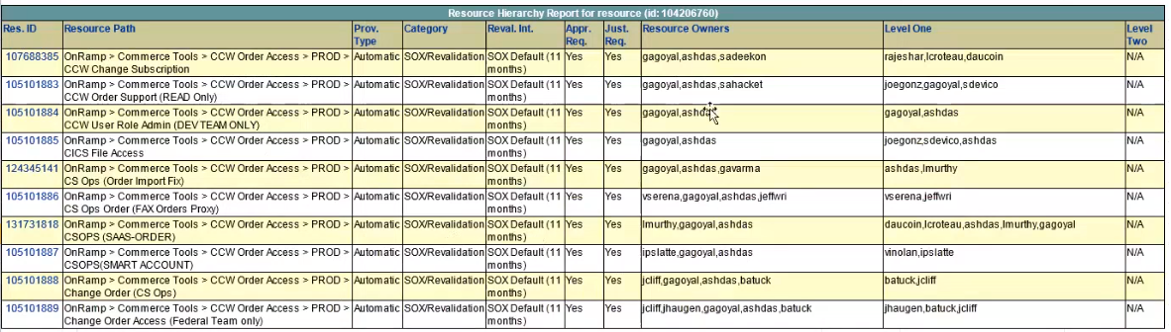

* For CCW order there are no admin roles are available so that’s why all the roles are configured with the interval of 11 months revalidation
* Admin roles need to be configured from 3 months
* If we have 3 months for Admin roles then we have to work with the corresponding “Resource Owners and get it updated to 3 months

**CCW CA19 for Quoting:**

* In quoting it is “AutoProvisioning”,so that’s why we have to do user sync and role sync as well
* Here we have 3 types of roles

a. End User Roles

b. Admin UI Roles

c. Super User Proxy Admin

* In onRamp🡪CommerceTools🡪CCW Quoting Access🡪PROD

These all 3 types of roles are available

* We have to do role sync for Quoting
* For these 3 different types of roles all these data will be stored in different tables (3 different type of screenshots)

**a.CCW Quoting End User Roles:**

* the access is provided through PDB Admin(PDBPROD).It is different database
* then the data has put into DMPROD
* when the data has come to DMPROD database then only user will be able to login to CCW Application
* There will be connection between PDBPROD and DMPROD
* 
* After we run this query
* 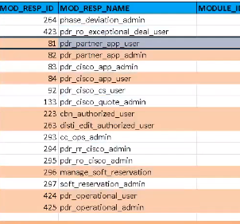
* All the highlighted roles are external users,but onramp we can enable for internal Users. Only Internal users can login to onRamp.No disti’s or partners can login into onramp and get access for.
* So we have to do role sync for remaining roles
* These 9 roles are there in onramp also.we have to provide mapping for these 9 roles

**b. CCW Admin UI User roles:**

* Admin UI is directly from DMPROD database
* Admin UI roles access is provided based on these LOV_INDEX
* 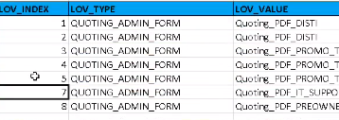

**c.CCW Quoting Proxy Admin**

* These Proxy admin roles are in different table
* Any user who request for proxy admin in OnRamp,the details will be stored in this table



These are all the dump from the application

So same way we take the query from onRamp,all the roles are configured in the same path and perform VLOOKUP in two ways

* Validating if role in application exist in onramp
* Validating if role in onramp exist in application

VLOOKUP is performed based on the resource_id available from application query and onramp query.It is performed in 2 ways.

1.validating if the resource_id and user_id available in the application is present In onramp

2. validating if the resource_id and user_id available in the onramp is present In application

**Resource Hierarchy:**

It is same like how we did for order

We have to take all the roles which are there in the particular parent_resource_id and we have to see if there are any admin roles.

We have to ensure that all these admin UI roles are put it for 3 months revalidation